EXPERIMENT NO : 4 DATE :

**BASIC LINUX COMMANDS ACTIVITY QUESTIONS**

1.Command to display the following message as such (Use ” and Newline).

"God! Bless us..

We are starting Shell Scripting"

-> echo -e "God! Bless us....\n We are starting shell scripting"

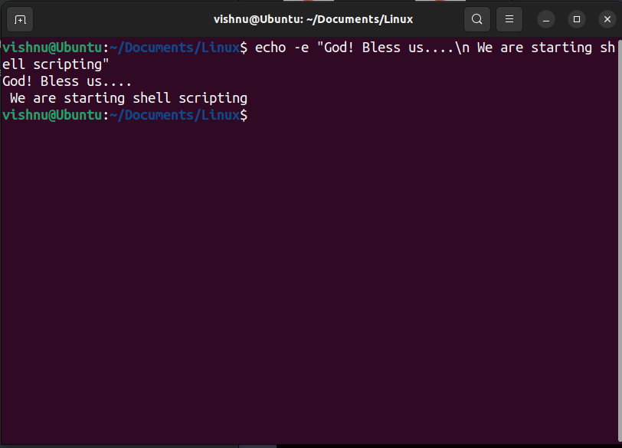

2. Get the manual page of ’ls’ command. Search for the word ”alphabetic”. Find the next occurrence and then find the previous occurrence.

-> man ls

press '/' and type "alphabetic", press enter.

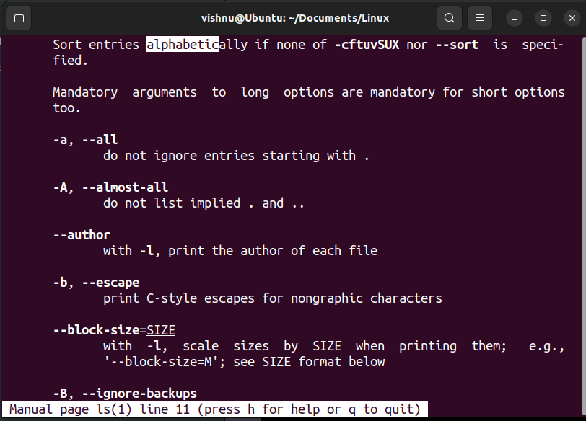

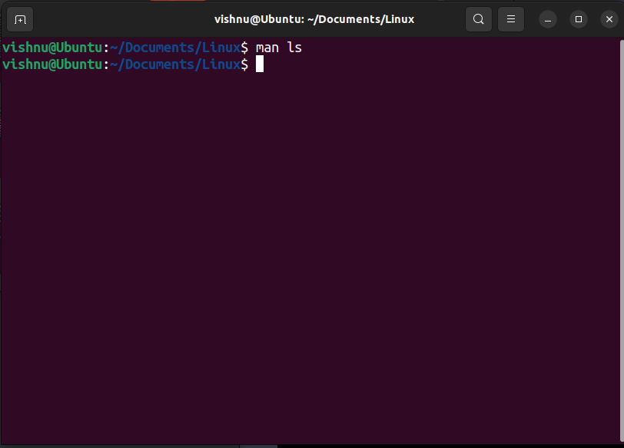

3. Read your name from the keyboard and display it

-> echo "Enter your name";read name; echo "The name entered is $name";

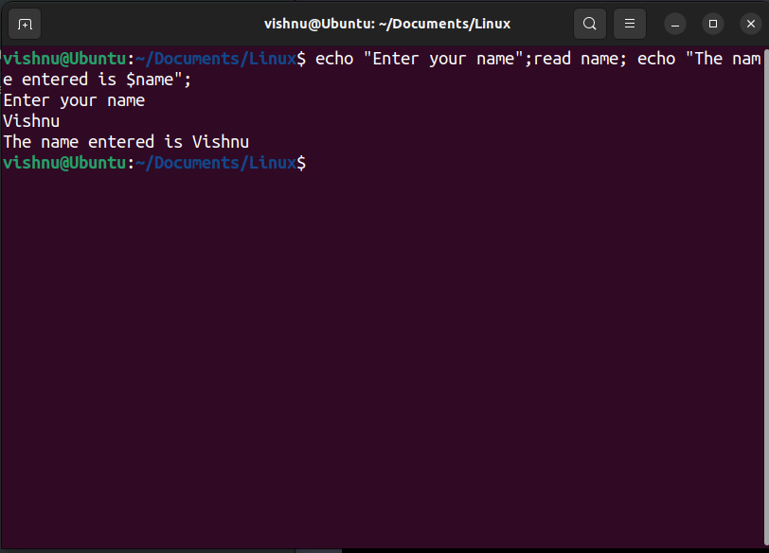

4. Create the directory structure dir1/dir4 and dir1/dir2/dir3 with a single command and then change directory to dir3

-> mkdir -p dir1/dir2/dir3

cd dir1/dir2/dir3

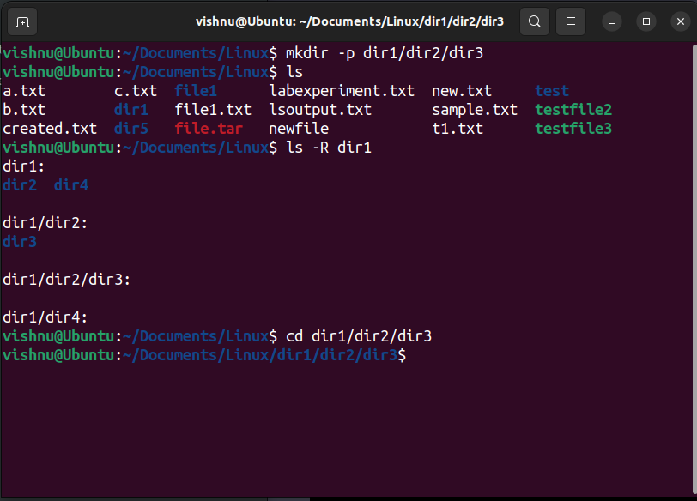

5. Create some files using Vim

-> vim text.tx, vim text1.txt, vim text3.txt

this will create a new text file named text

press "i" to get into insert mode, Type contents into the file press 'Esc' key to exit insert mode, type ":wq" to save and exit.

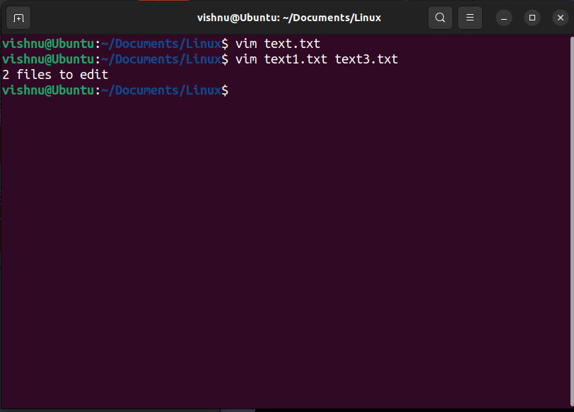

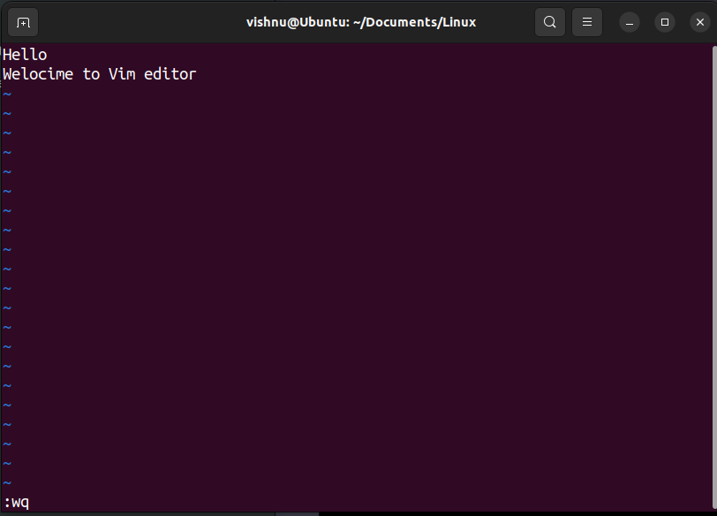

6. Display the current directory

-> pwd

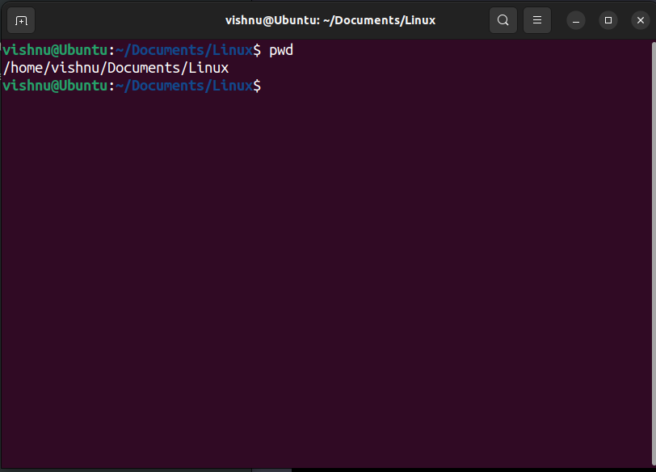

7. Listing Files and folders

* 1. List the contents of dir1 (Qn. 4) and all its descendants
  2. List the contents of dir3 (Qn. 4) in
     1. Alphabetical Order
     2. Sorted on Time of modification, newest first
     3. Sorted on Size
     4. Reverse of all above
     5. Long listing of files Sorted on Size with smallest first and size
     6. displayed in human readable form

-> a) ls -R

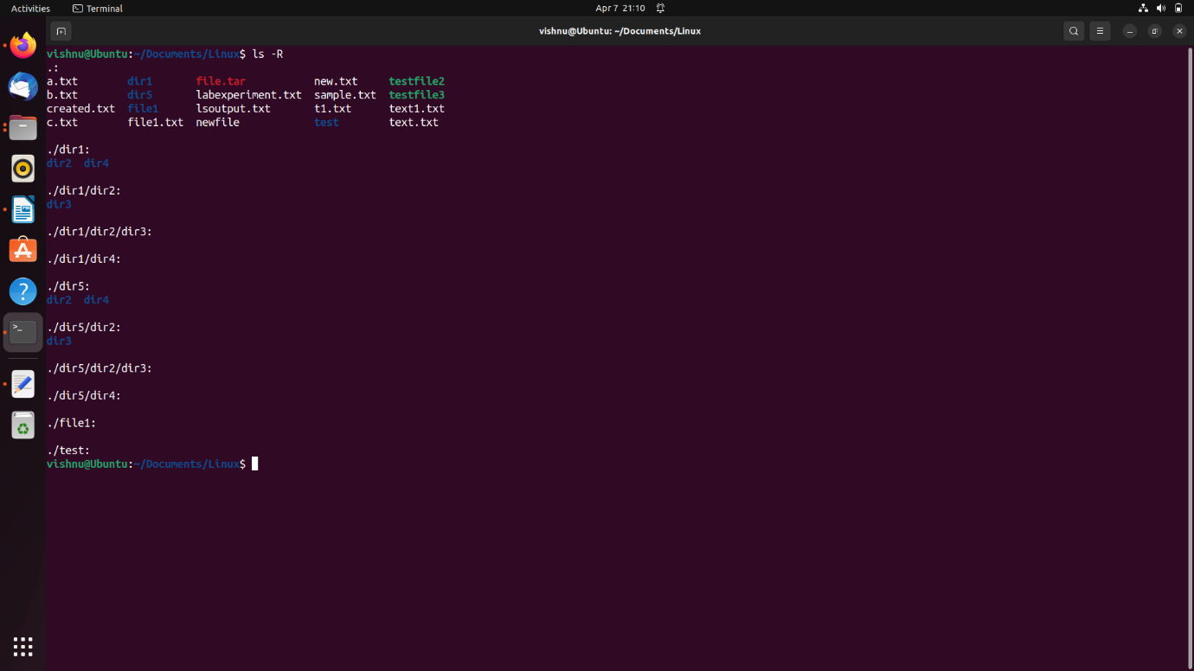

b)

i) ls -v

ii) ls --sort='time'

iii) ls --sort='size'

iv) ls -r

v) ls -ls

vi) ls -hs

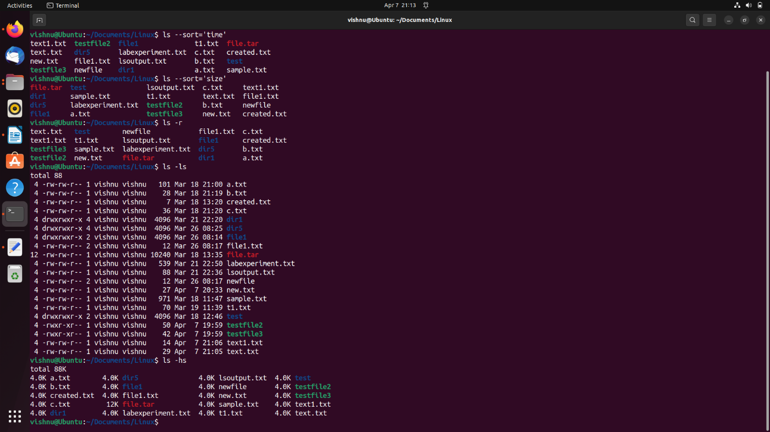

8. Execute ls and store the output to a file lsoutput

-> ls > lsoutput.txt

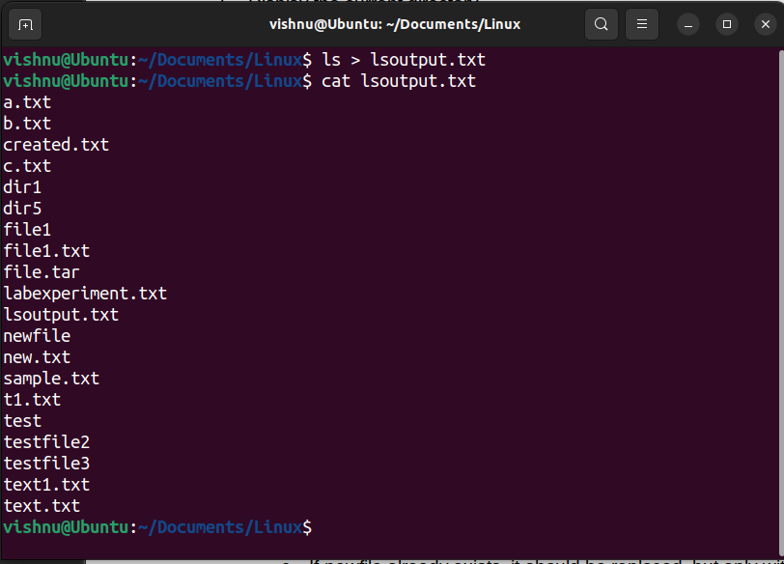

9. Display the file

a. starting with the first 10 lines and

-> head labexperiment.txt

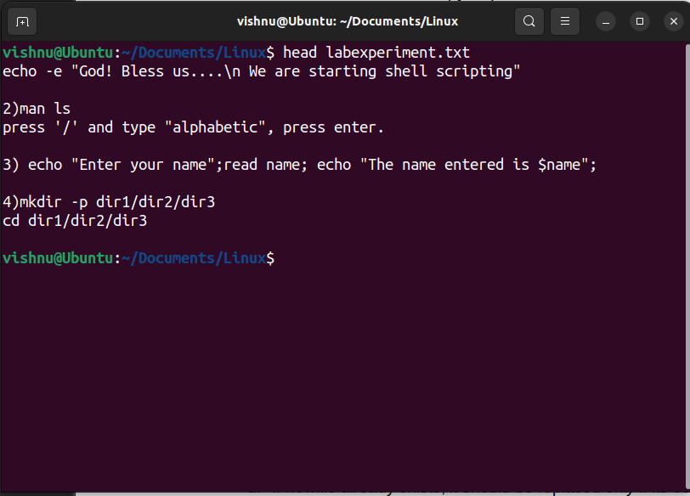

b. starting with the 10th line with provision for

i. Scrolling Up

ii. Scrolling Up and Down

-> i) more -10 labexperiment.txt

ii) less +10 labexperiment.txt

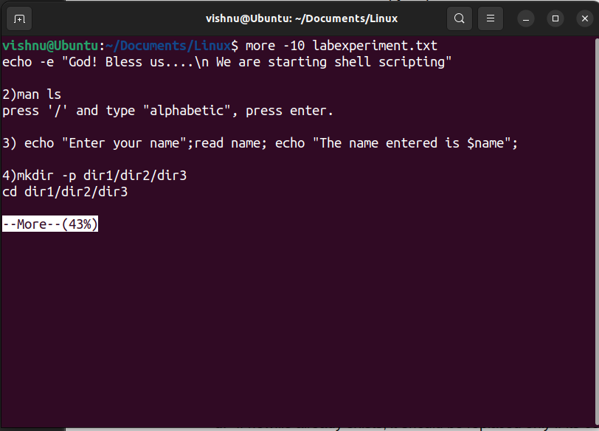

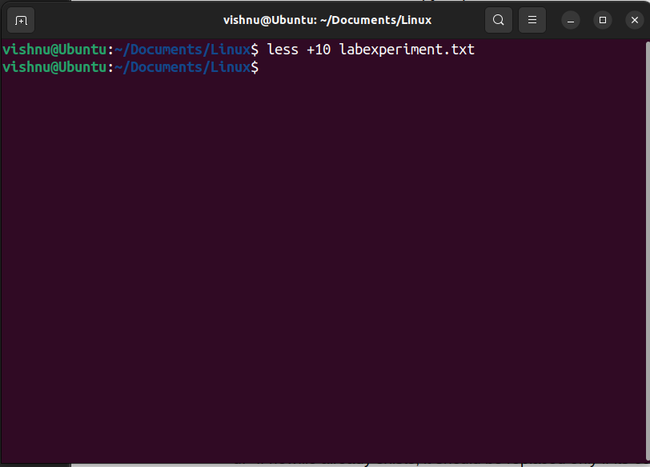

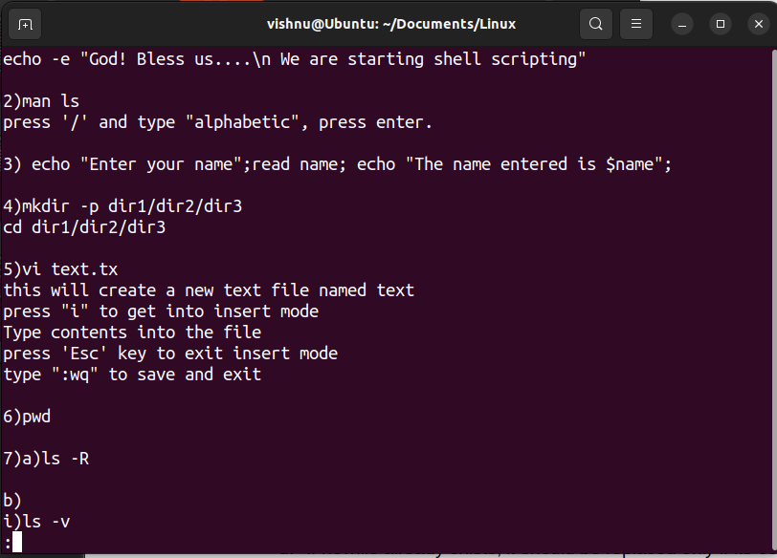

10. Execute ls -l and add the output to lsoutput, at the end.

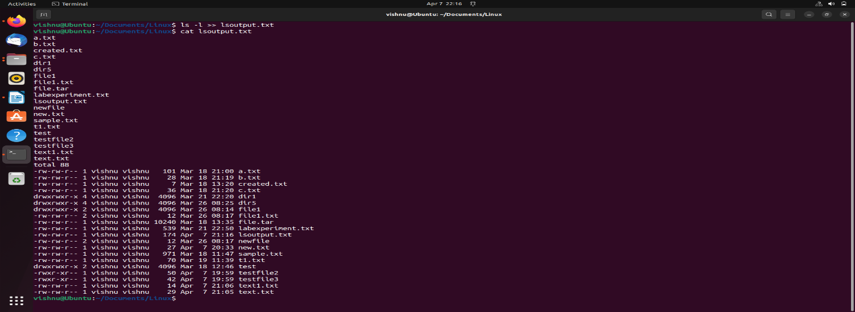

11. Execute ls -l and feed the result to less command, to scroll through the directory listing.

-> ls -l | less

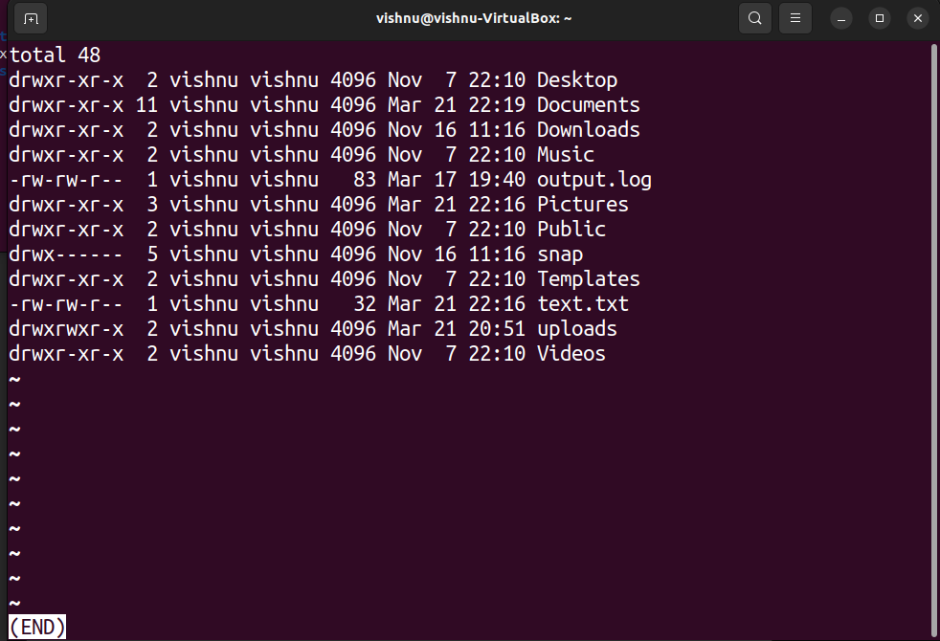

12. Copy the file file1 to newfile.

a. If newfile already exists, it should be replaced.

b. If newfile already exists, it should not be replaced.

c. If newfile already exists, it should be replaced, but only with the consent of the user.

d. If newfile already exists, it should be replaced only if its contents is older than that of file1.

e. Even if newfile is read only.

f. Create a link instead of copying.

g. Copy the entire directory tree from dir1 of Qn.4 to a new directory dir5.

->

a) cp -f file1.txt newfile

b) cp -n file1.txt newfile

c)cp -i file1.txt newfile

d) cp -u file1.txt newfile

e) cp -f file1.txt newfile

f) ln file1.txt newfile.txt

g) cp -r dir1 dir5

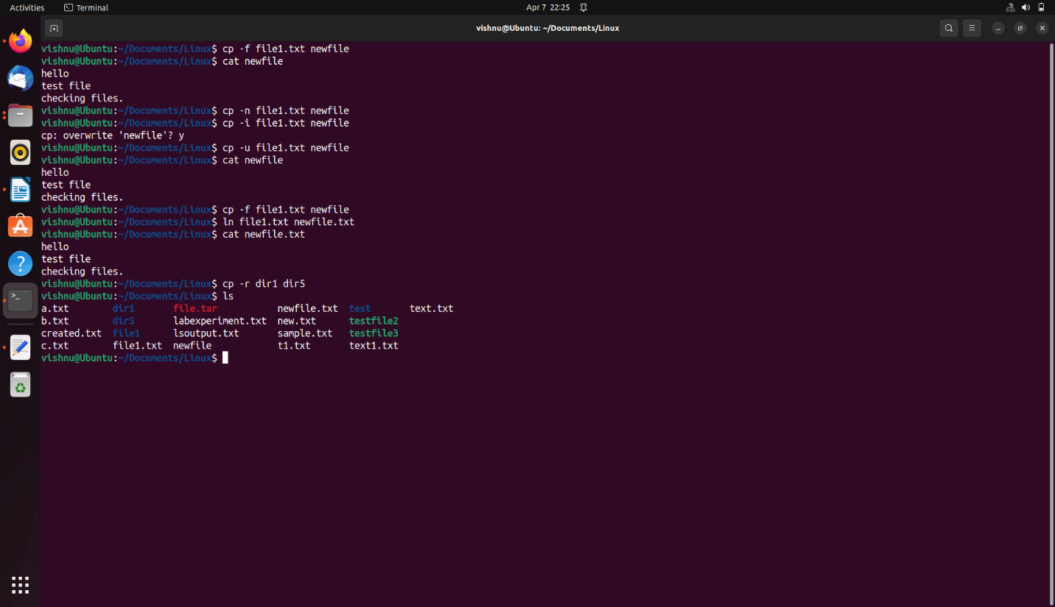

13. Create a new directory, dir6 inside dir1

a. Move all files in dir5 into it.

b. Delete all files where the name starts with a vowel character, upper or lower case.

c. Delete all files where the name is at least 3 characters long.

d. Delete all hidden folders, and files.

->

a) mkdir dir1/dir6

mv dir1/dir5/* dir1/dir6/

b)

c)

d)

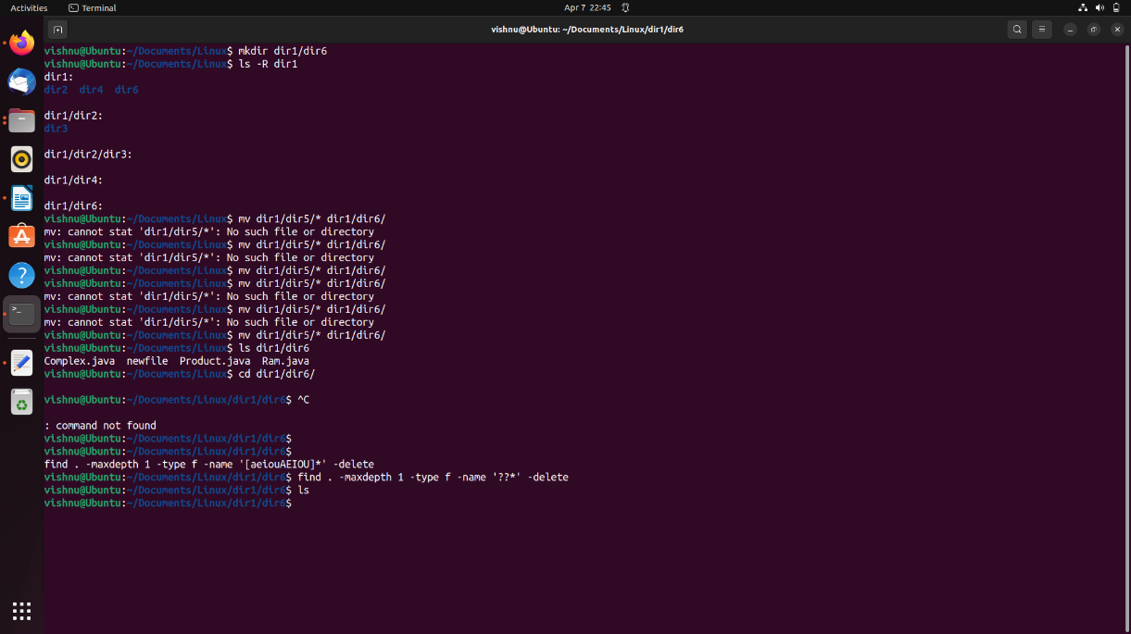

14. Create a file testfile1 using Vim

a. Set line number

b. Type your name and address with district and pincode

c. Copy paste the contents 10 times

d. Replace all occurrence of your district with a neighbouring district.

-> vim testfile1

a) In Vim command mode type “:set number”

b)Jeevan , 12B Skyline,Vazhuthakkadu, Trivandrum

c)Move the cursor to the end of the line, in command mode type ‘yy’

type ‘10p’

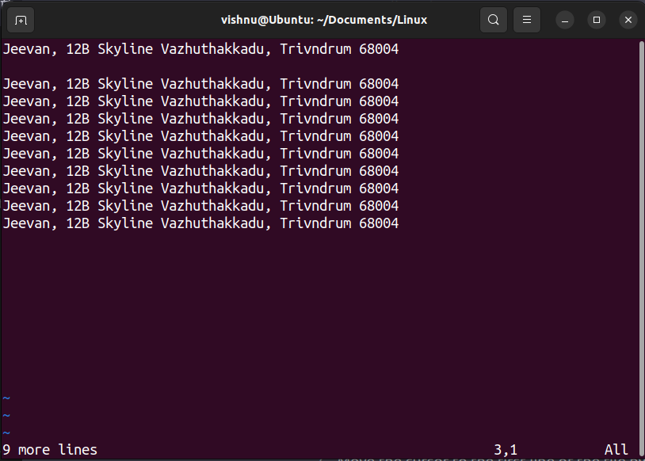

d) In command mode “:%s/Trivandrum/Kollam/g”

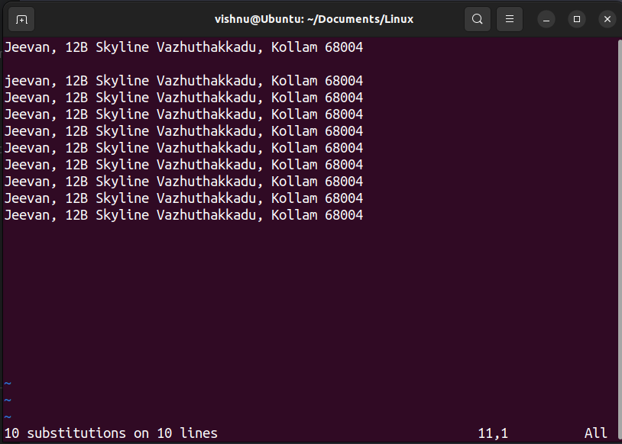

15. Create 2 files testfile2 and testfile3 using **Vim**.

* 1. Modify the permissions of testfile2 using symbolic mode.
     1. Add read permission to others
     2. revoke write from owner
     3. set only execute to Group.
     4. add write to owner, revoke read from others and set read only to group.
     5. set read and write to all
  2. Modify the permissions of testfile3 using numeric mode
     1. Set read and write to all
     2. set read,write and execute to owner, read and execute to group and read only to others
  3. Set the permissions of testfile2 the same as that of testfile3

-> vim testfile2, vim testfile3

a)i) chmod o+r testfile2

ii)chmod u-w testfile2

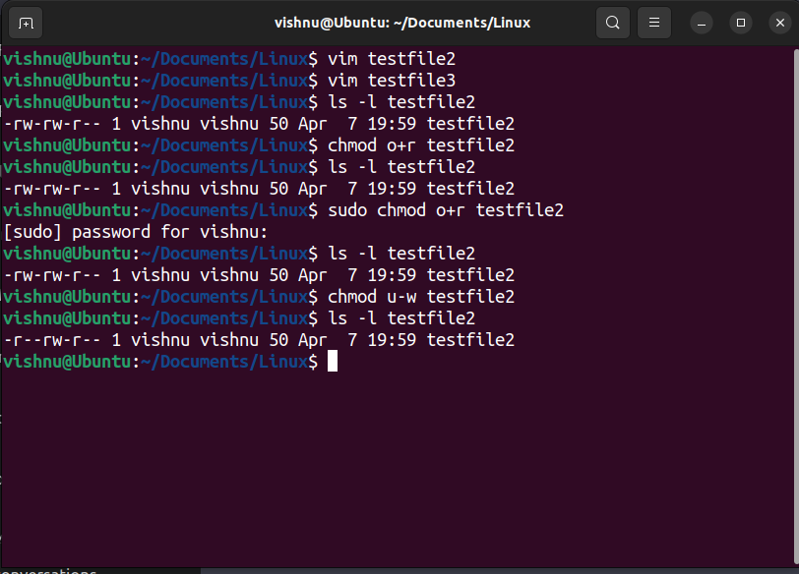

iii) chmod g+x testfile2

iv) chmod u+w testfile2

v) chmod o-r testfile2

vi)chmod g+r testfile2

vii)chmod a+rw testfile2

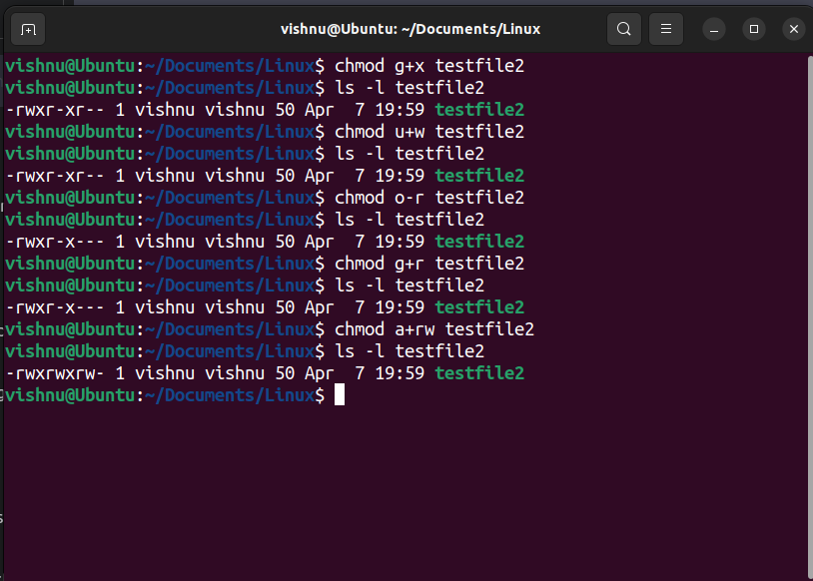

b)

i) chmod 666 testfile3

ii) chmod 754 testfile3

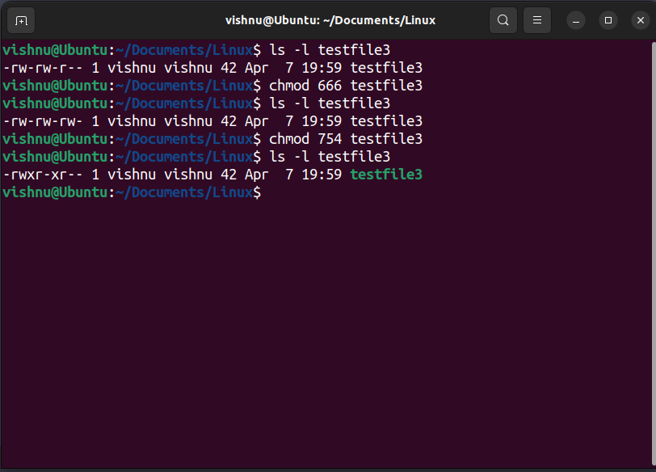

c) chmod --reference=testfile3 testfile2

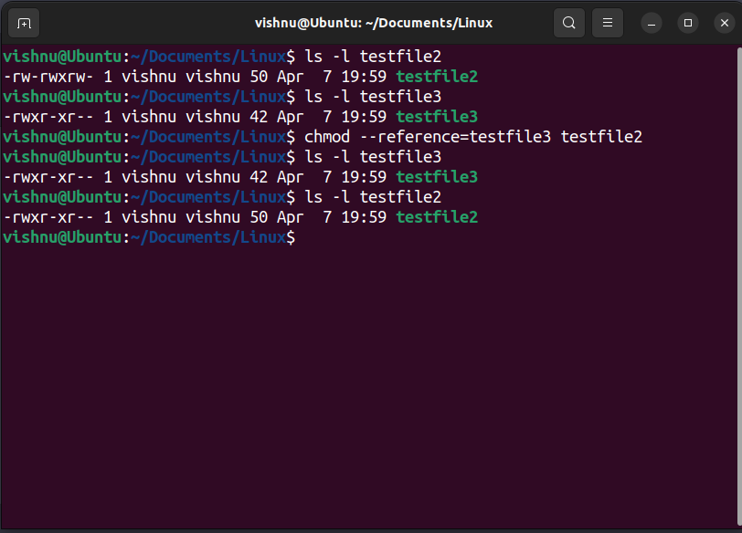

16. Use **head** and **tail** piped with cat /etc/passwd to display the details of

* 1. The first 12 users in the system.
  2. The last 7 users in the system.
  3. All but the first 3.
  4. All but the last 5.
  5. Only the 9 th.

->

a) cat /etc/passwd | head -n 12

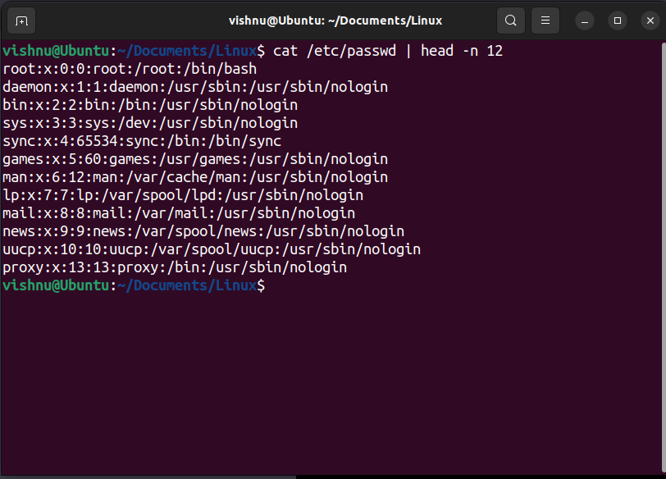

b)cat /etc/passwd | tail -n 7

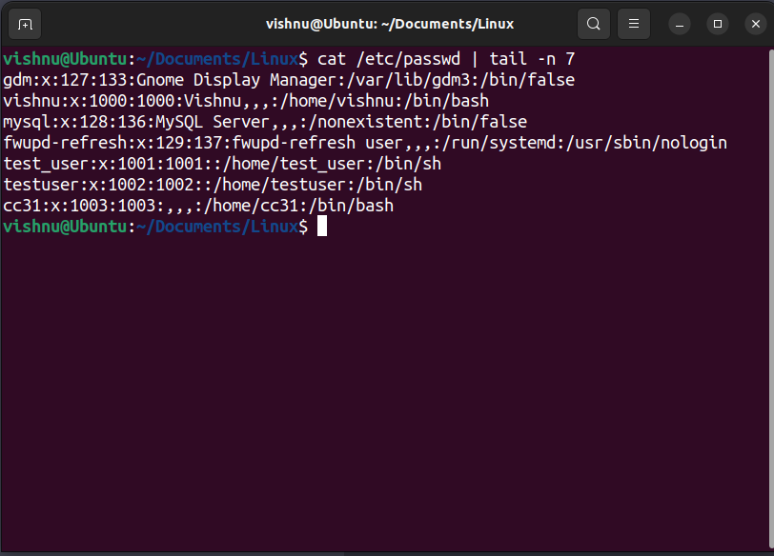

c)cat /etc/passwd | tail -n +4

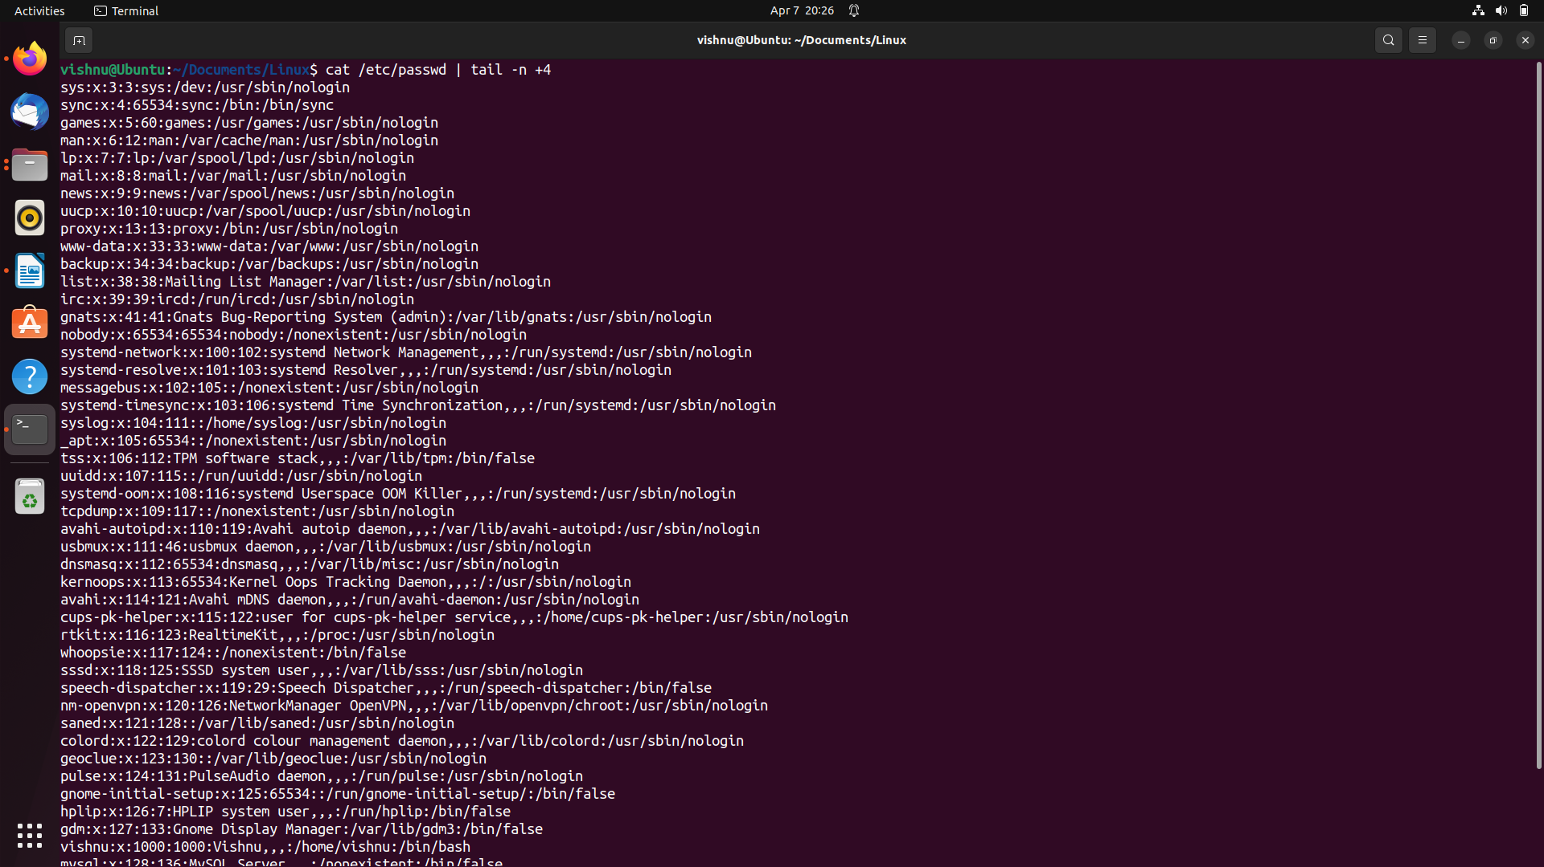

d)cat /etc/passwd | head -n -5

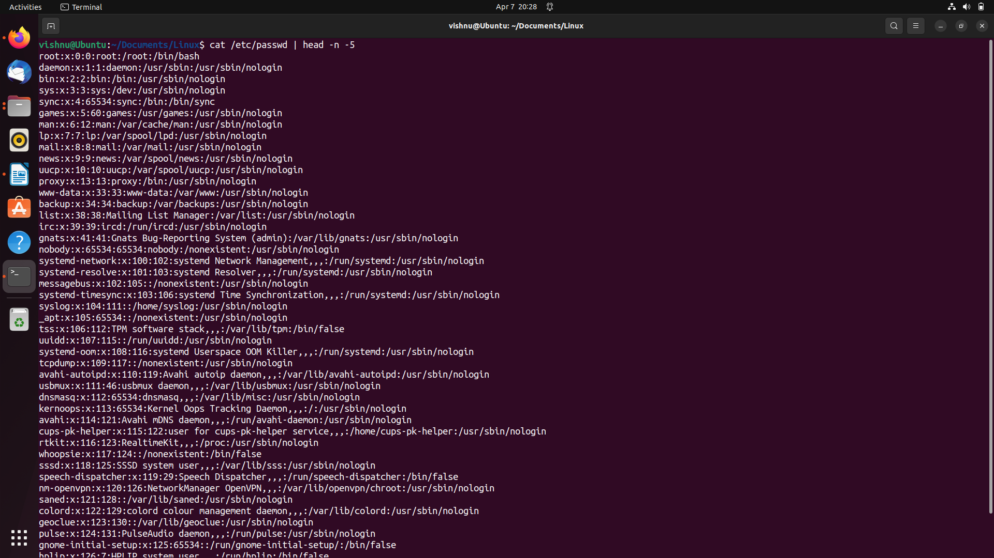

e)cat /etc/passwd | head -n 9 | tail -n 1

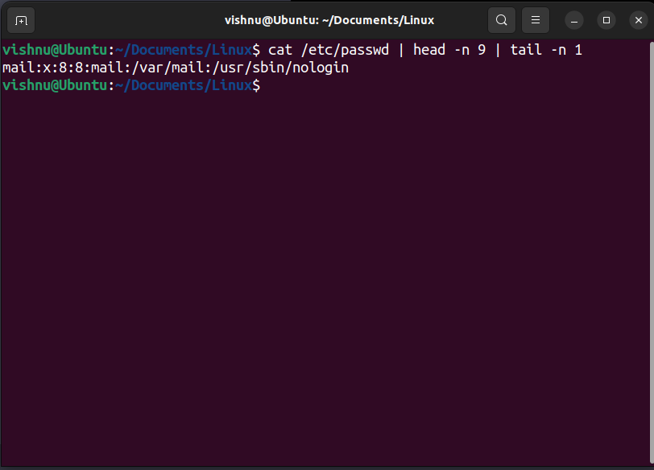

17. Use grep to

a. Display all lines in a file that contains the string “abc”

b.Display all lines in a file that does not contain the string “abc”

->

a) grep “abc” /home/vishnu/Documents/Linux/new.txt

b) grep -v “abc” /home/vishnu/Documents/Linux/new.txt

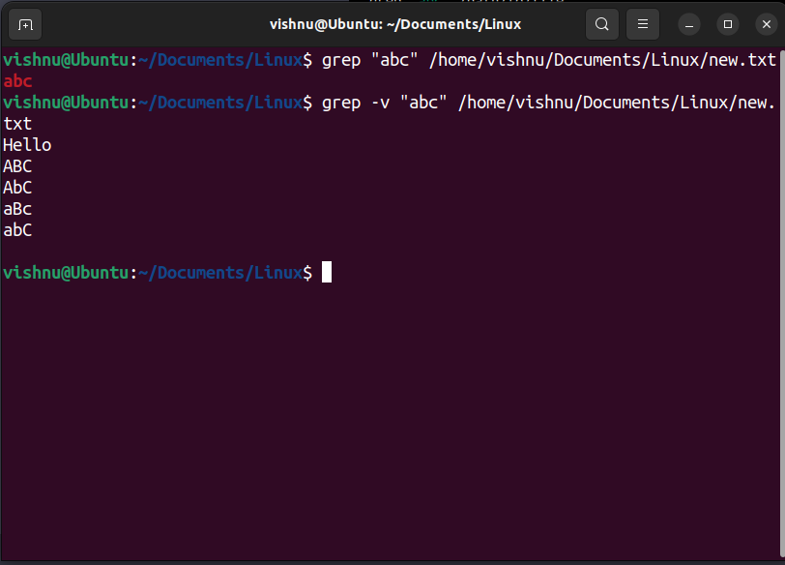

18. Using **expr**

* 1. Read two integers X and Y. Display the sum, difference, product, quotient and remainder of these variables.
  2. Read a string, S, a position, p and a length l. Display the substring of length l starting at position p from the string S

->

a)echo “Enter the value of X:”

read X

echo “Enter the value of Y:”

read Y

sum=’expr $X + $Y’

Echo “Sum : $sum”

diff =’expr $X - $y’

Echo “Difference : $diff’

prod=’expr $X \* $Y’

echo “Product : $prod”

quot=’expr $X / $Y’

echo “Quotient: $quot”

rem=’expr $X % $Y’

echo “Remainder: $rem”

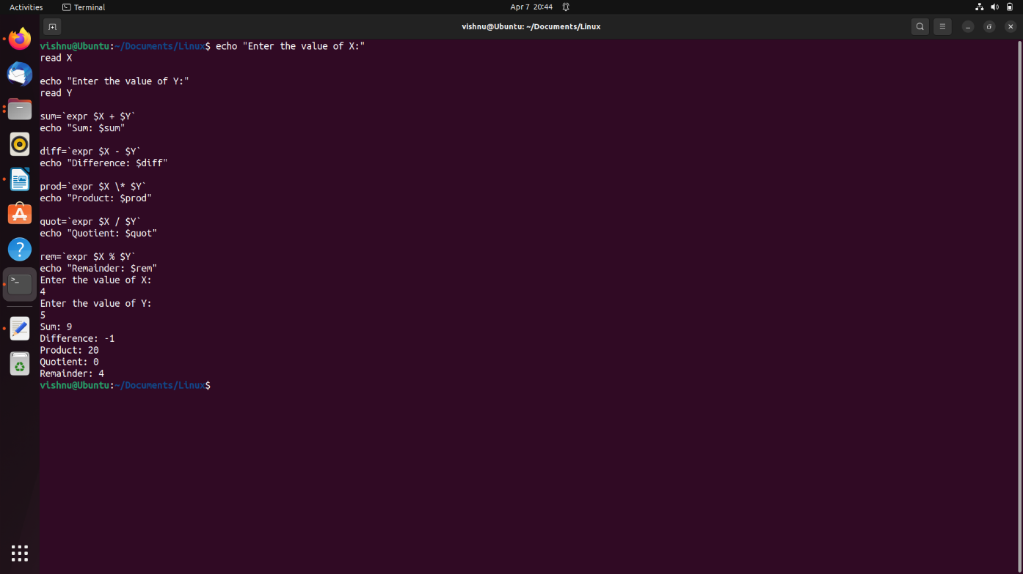

b) echo “Enter a string:”

read s

echo “Enter the starting position:”

read p

echo “Enter the length of substring:”

read l

substr=’expr substr “$s” $p $l’

echo “Substring: $substr”

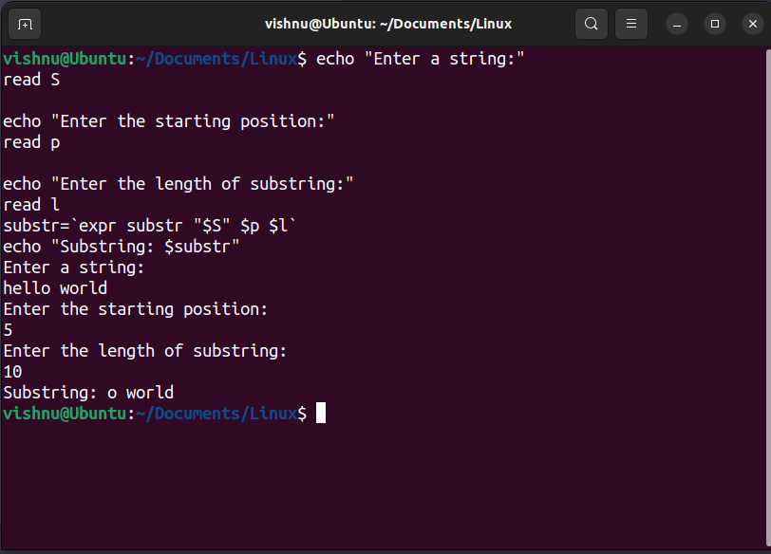

20. Miscellaneous

* 1. Using **tar** create a tar.gz file of the folder dir1 of Qn.4 with the name *mydir.tar.gz*
  2. Extract the contents of *mydir.tar.gz* to dir6 of Qn.14
  3. Use **top** to display processes sorted on
     1. ProcessId
     2. CPU%
  4. Use **ps** to display
     1. Processes associated with the current terminal
     2. All processes in the system
  5. Use **df** to display the storage available in each partition in human readable form.

->

a) tar -czvf mydir.tar.gz dir1

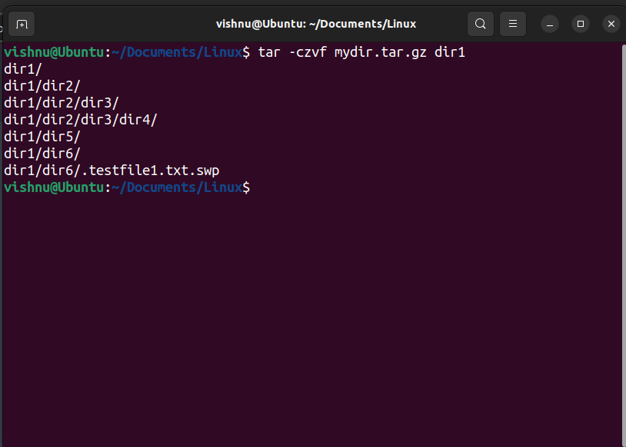

b) tar -xzvf mydir.tar.gz -C dir1/dir6

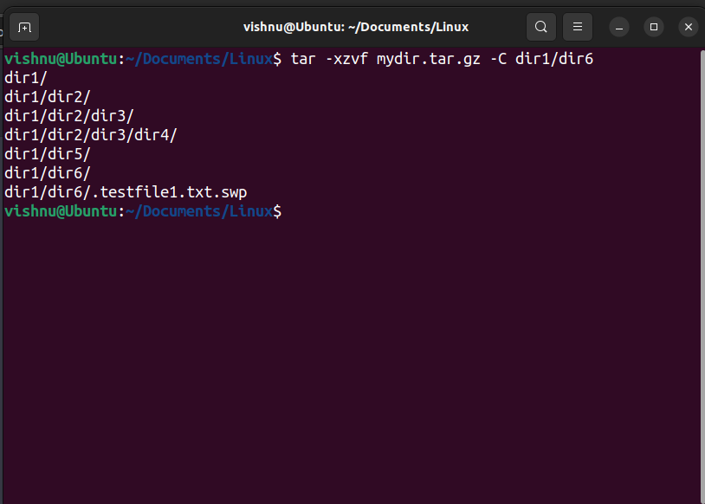

c)

i)top -o PID

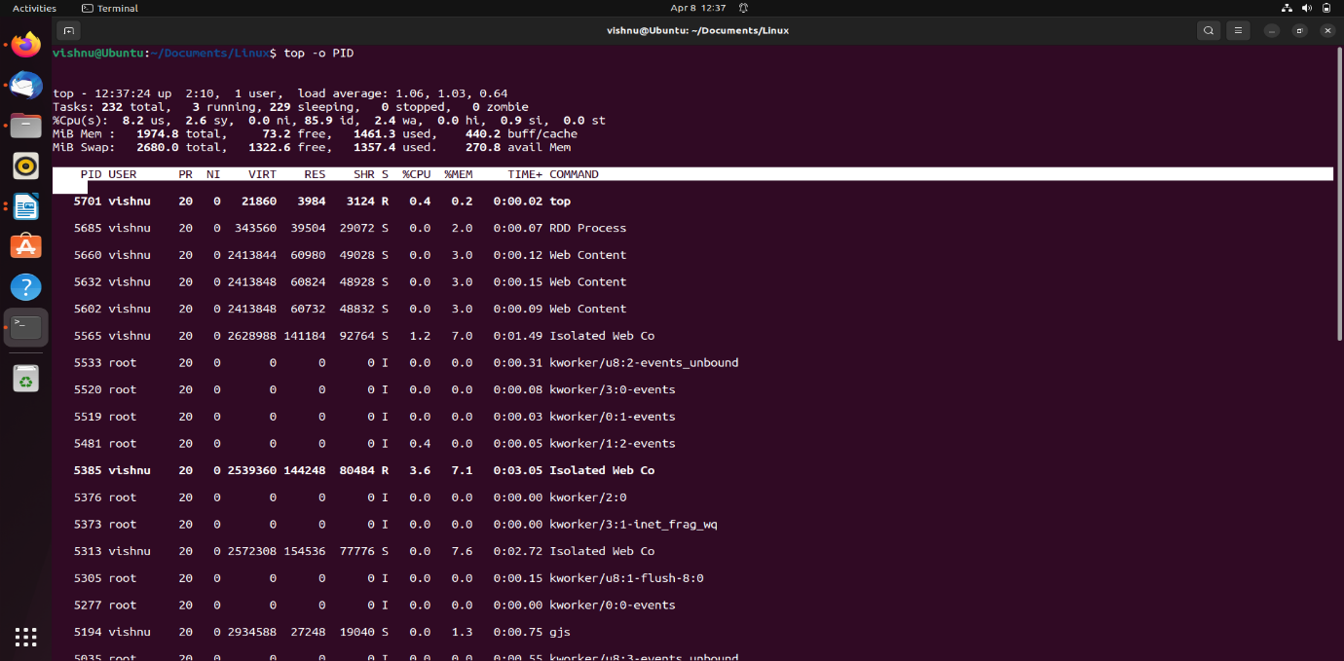

ii) top -o %CPU

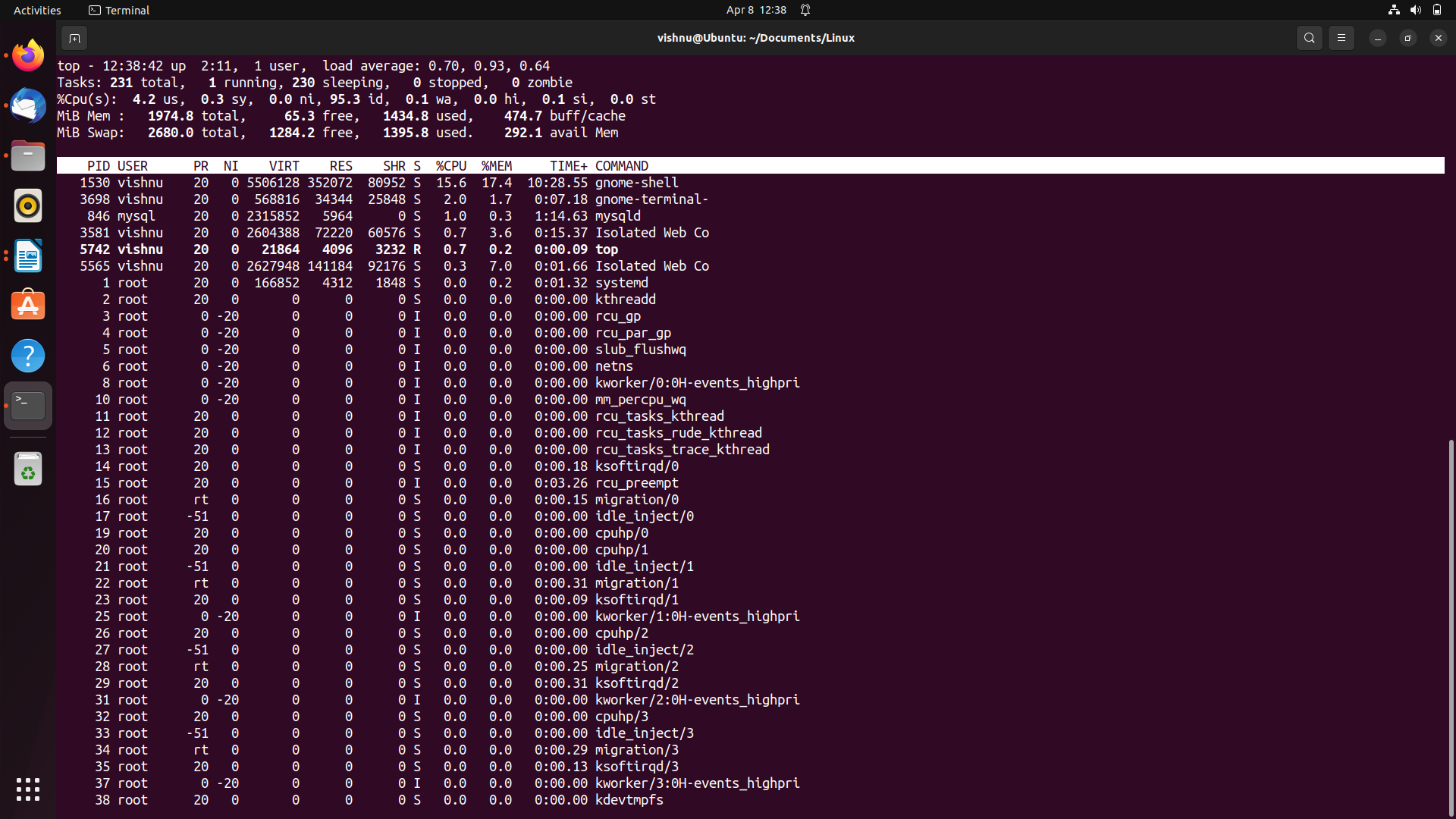

d)

i) ps -t $(tty)

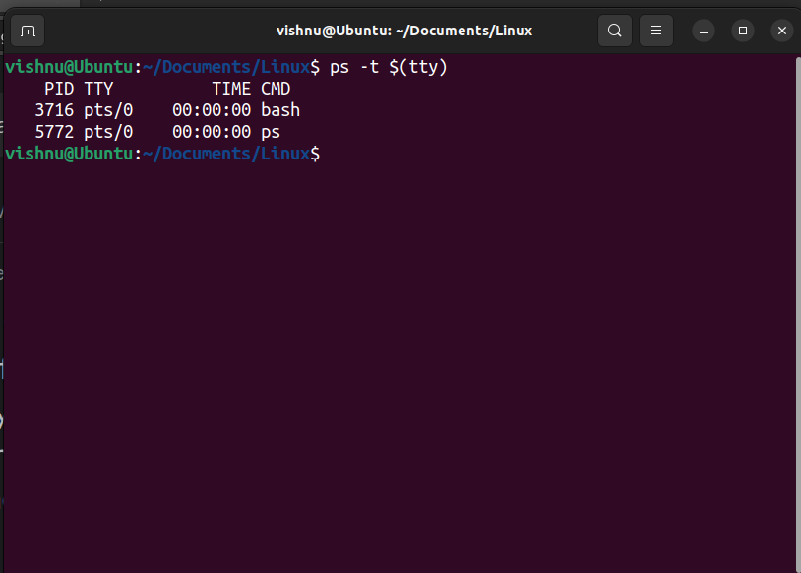

ii) ps aux

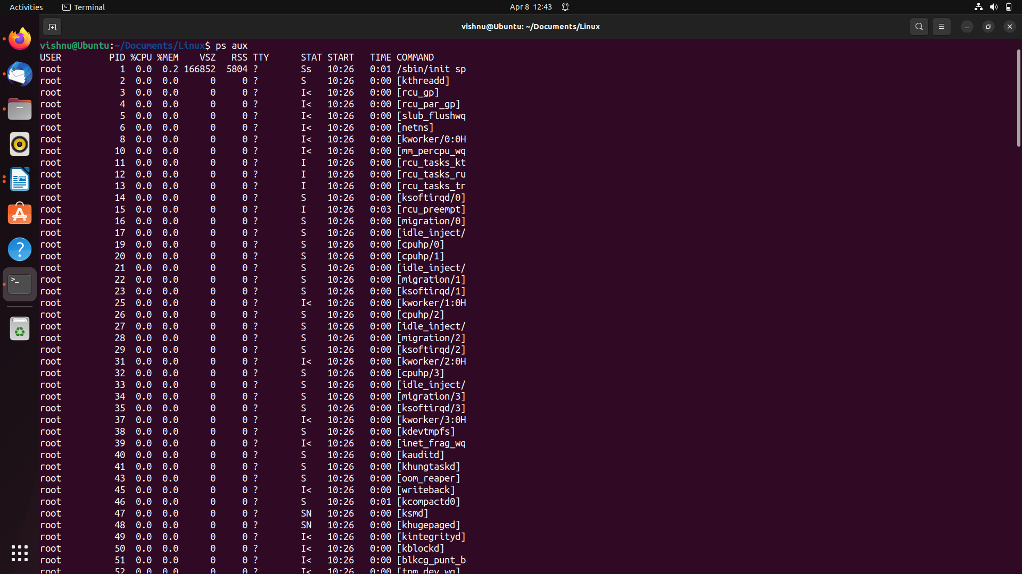

e) df -h

